In this example we show how to create an enhanced menu in the transaction KO02.

Open KO02 and get the program name in system>status: SAPMKAUF

Open the program in SE38/SE80 and get the package name on “Object Directory Entry”: KAUF

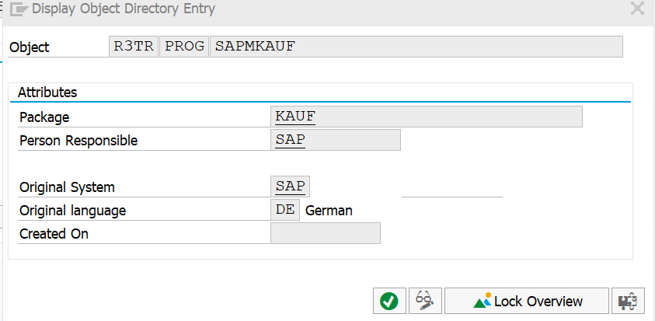

Go to tcode SMOD and use the search-help using the package name to find a menu exit:

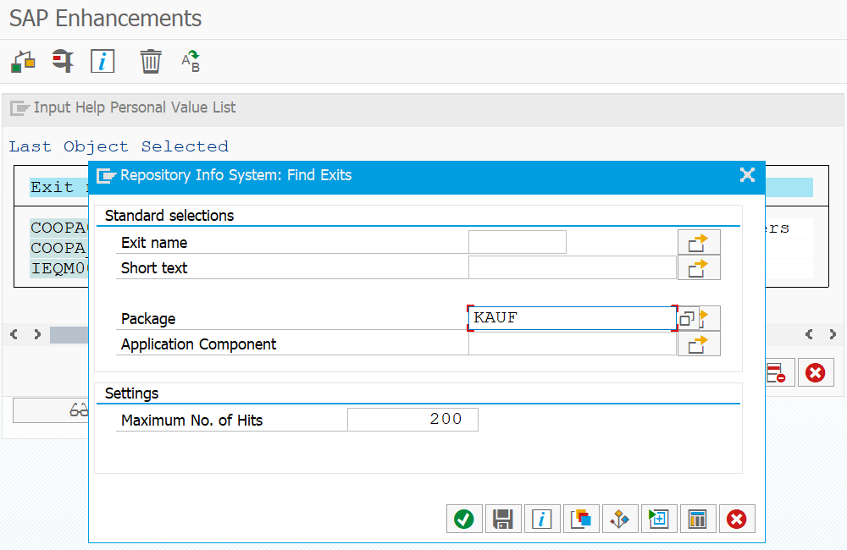

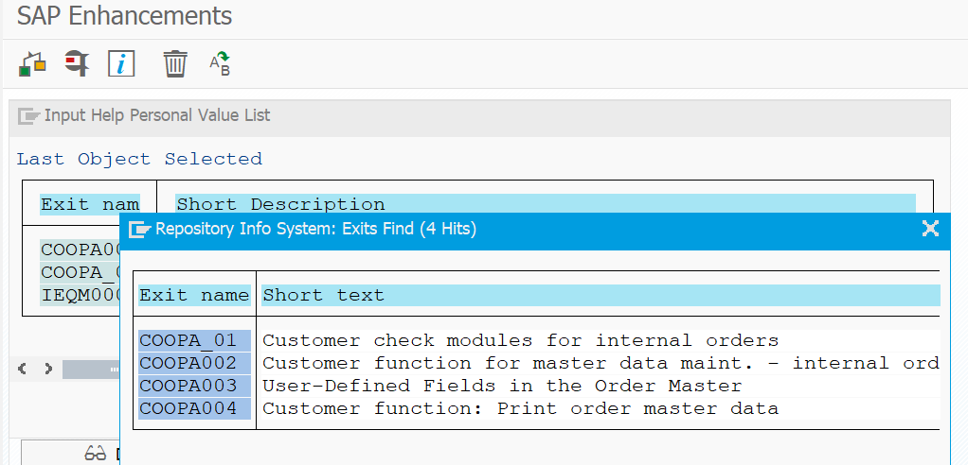

By looking the documentation, we can see that exit COOPA002 is the menu exit we need.

This exit has a Program and a function model:

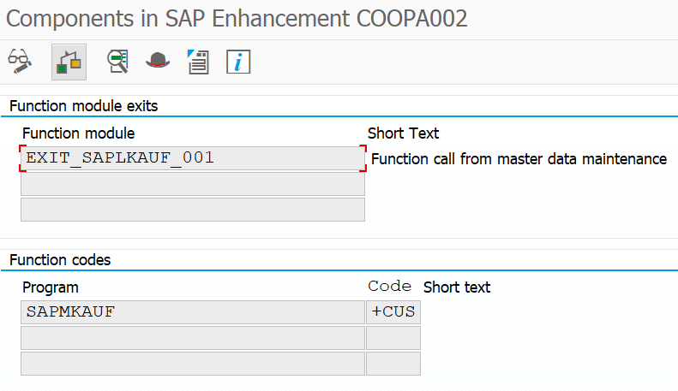

Go to tcode CMOD to start the enhancement.

After creating the enhancement project we see that it has a function exit and a Menu exit. By double-clicking the Menu exit program name we can define the menu button text that will be shown to the user:

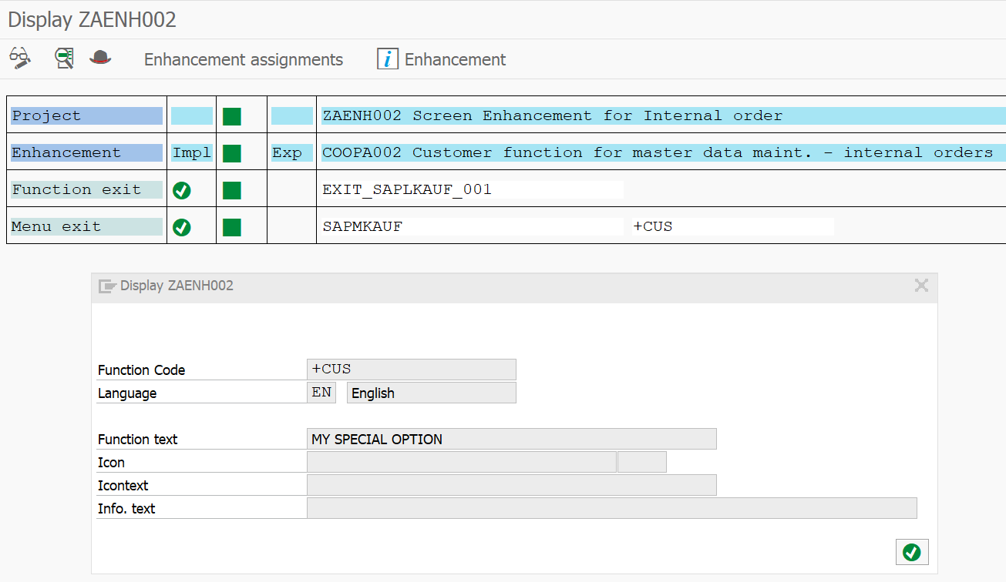

In this example, we want our special menu button to automatically update some fields in the screen.

Double-click the FM. The tab CHANGING contains the parameter structure that we can change in the screen.

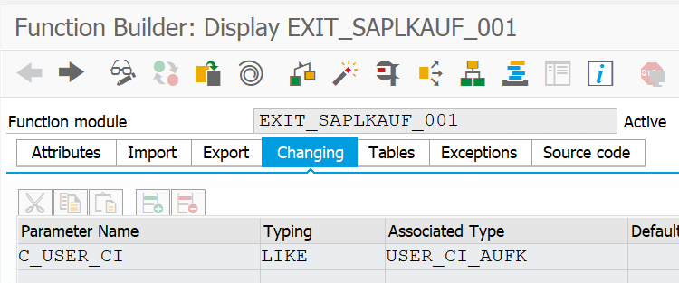

I decided to update the following fields:

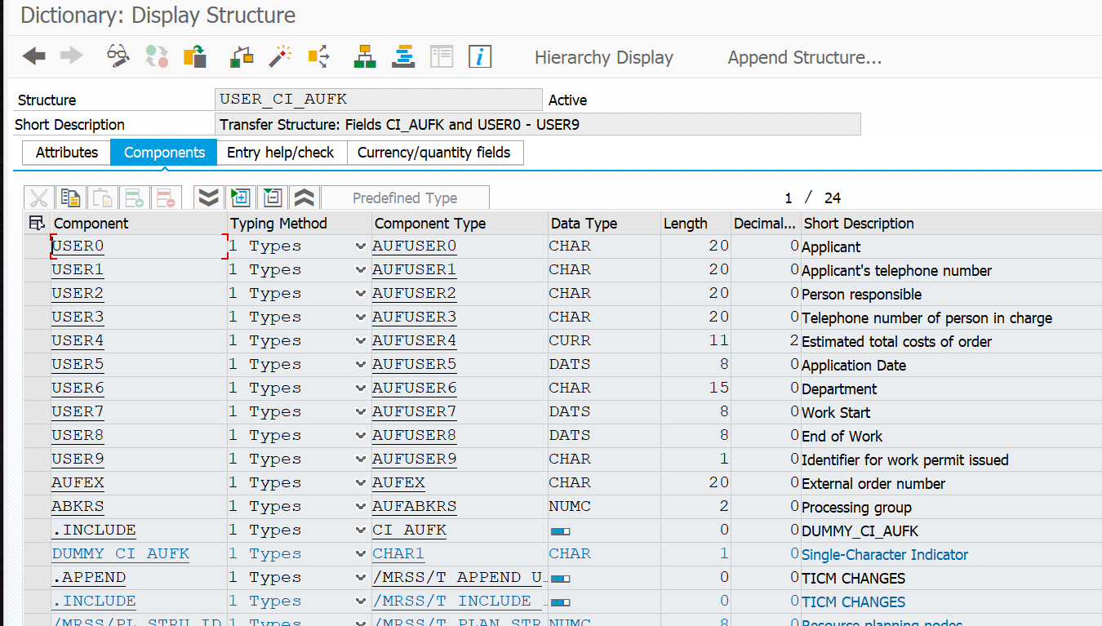

*&---------------------------------------------------------------------*  
*&  Include           ZXAUFU03  
*&---------------------------------------------------------------------*

DATA : user     TYPE syuname,  
       usr_data TYPE qisrsuser_data.  
  
  
user = sy-uname.  
  
CALL FUNCTION 'ISR_GET_USER_DETAILS'  
  EXPORTING  
    id_user_id     = sy-uname  
  CHANGING  
    is_user_data   = usr_data  
  EXCEPTIONS  
    user_not_found = 1  
    OTHERS         = 2.  
  
c_user_ci-user2 = usr_data-fullname.    "User Name  
c_user_ci-user3 = usr_data-tel_number.  "User Phone Number  
c_user_ci-user4 = 10000.                "Estimated Total Cost  
c_user_ci-user5 = sy-datum.             "Application Date  
c_user_ci-user6 = usr_data-department.  "Department

In tcode KO02 go to the General tab:

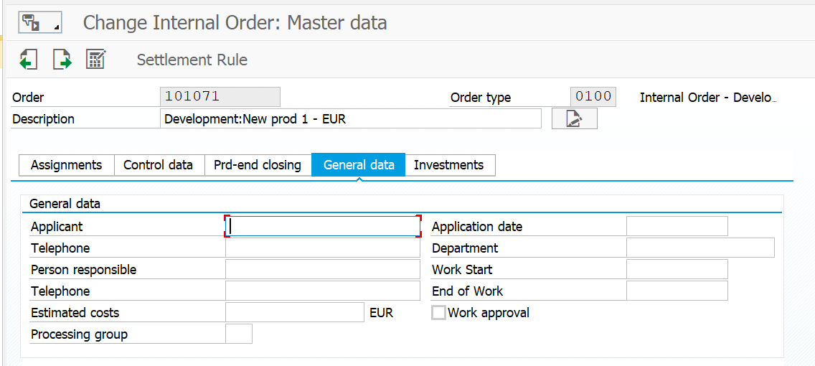

Access our new menu on Extras > MY SPECIAL OPTION

